**SSH to your AWS Workstation**

**ssh devops@<public-ip-addr**> of your Workstation  
Password is : **Dev0p$!!/**

**Replace <your-name> with your name throughout the lab.**

1. To list all the images available on the local repo run the below command.

|  |
| --- |
| $ docker images |

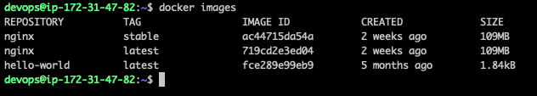

2. To run a container from the local image run

|  |
| --- |
| $ docker run -d -p 80:80 --name dockerdemo-<your-name> nginx:latest |

The above command will run the nginx container with the latest tag and in detached mode (-d) with ports 80 of nginx container mapped to the port 80 of Host machine. The --name switch is used to name the docker container.

3. To check the running Containers

|  |
| --- |
| $ docker ps |

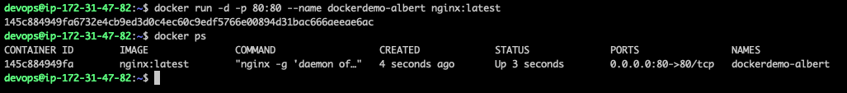

4. Open a web browser and browse the Public-ip-address of your AWS Workstation

You will be able to see the nginx welcome page that is running on the

Docker container.

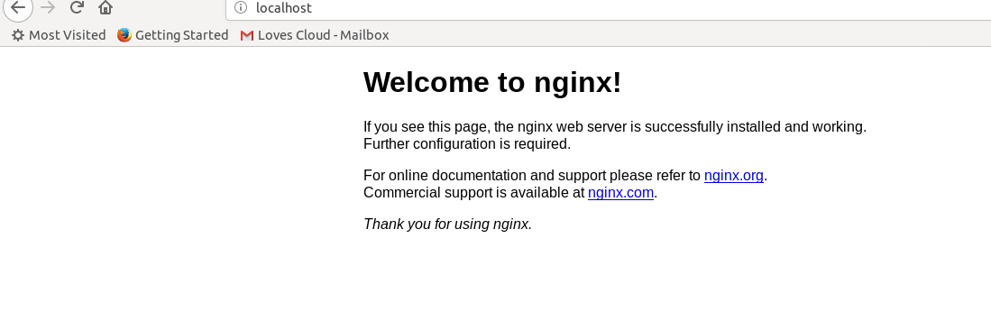

5. To stop a container do

|  |
| --- |
| $ docker stop dockerdemo-<your-name> |

6.And, to start a stopped container do

|  |
| --- |
| $ docker start dockerdemo-<your-name> |

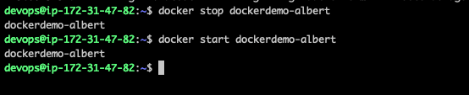

**7. STOP and remove the containers before proceeding to the next lab**

|  |
| --- |
| # docker stop dockerdemo-<your-name> |

8. Check all the container in stopped state

|  |
| --- |
| # docker ps -a |

9. To remove all the container in stopped state run the below command.

|  |
| --- |
| # docker rm $(docker ps -a -q) |